## DSC Subsystem

The DSC subsystem is represented by VHF Radio, DSC modem, DSC processing software.

### VHF Radio Spectra MX800

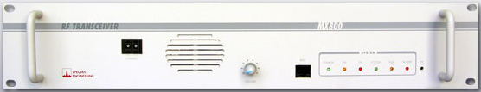

Figure 3‑16 –Spectra MX800

The MX800 VHF radio employs state of the art design and construction methods to deliver a range of high performance, ultra-reliable radio transceivers. They are ideally suited for use in VHF two-way voice radio systems, however, the MX800 can perform in a range of applications where the added advantage of linear frequency and phase response from DC to 3.4 kHz can be utilized. The MX800 uses a two-point modulation method synthesizer for extended low end VF transmit frequency response. The Receiver, Exciter and Power Amplifier are contained in their own specialized aluminum module and can be easily removed from the main chassis.

The MX800 is a compact lightweight standard 19" rack mounting transceiver. It is designed to mount horizontally in a 19" rack frame and occupies 2RU (89mm). The depth of the unit is 330mm and the weight is less than 9kg.

The unit consists of four main sub-assemblies an Exciter Module, a Receiver Module, a Power Amplifier Module and a Micro Controller board. These modules are housed in a fully welded steel case.

The MX800 features a high degree of RFI and EMI screening throughout the design and construction. The receiver and exciter (low power transmitter) modules are contained in solid aluminium enclosures, and for additional screening each interface pin in the modules is individually filtered. The PA module is contained in a special compact efficient extrusion for minimum harmonic radiation. This design results in low conducted and radiated emissions and minimal susceptibility to RFI and EMI.

User interface is via the front and rear panels. The rear panel provides access to all connectors and the standard front panel provides 6 LED indicators of the radio status. The local control option front panel has additional speaker, microphone and (optionally) channel select functions. Other variations can accommodate serial and monitor ports, as well as VF line level adjustment on the front panel.

|  |  |
| --- | --- |
| General | |
| Synthesis Method: | Non-mixing PLL. Fractional N synthesizer. |
| Modulation: | Direct FM two-point method. |
| System Deviation: | +/-5.0kHz max (WB), +/-2.5kHz max (NB) |
| Channel Spacing: | Programmable 25kHz/12.5kHz. |
| Channels: | 255 Software or switch selectable,  0-99 BCD or 255 Binary parallel selection. |
| Supply Voltage: | 13.8 +/- 20%. |
| Power Consumption: | <500 mA receive, typ 460mA. 220mA opt. <10A for 50W Model, TX RF output. |
| Operating Temperature: | -30 to +60C (-22º to 140ºF), -30 or -40C test option. |
| MX800 Size: | 2RU Case, 325mm deep including fan. |
| Weight: | <9Kg |
| Standard LED indicators: | Power, RX, TX, CTCSS, Aux/Lock, Alarm. |

|  |  |
| --- | --- |
| Transmitter  MEASURED IN ACCORDANCE WITH TIA/EIA-603 STANDARDS | |
| RF Power Output: | 1W to 50W variable. |
| Frequency Stability: | 2.5PPM. |
| Audio Response: | Flat within +1,-3dB across BW. |
| Audio Bandwidth: | DC to 3400Hz (DC FM input). 300Hz to 3400Hz (VF input). |
| Modulation Distortion: | Less than 2% @ 60% deviation. |
| Modulation Limiting: | 12.5 kHz channel ±2.5kHz.  25 kHz channel ±5kHz . |
| Spurii and Harmonics: | More than 100dB below carrier. |
| RF Switching Bandwidth Exciter: | Same as band allocation. |
| RF Switching Bandwidth PA: | Same or greater than band allocation. |
| Duty Cycle: | 100% for PA rated RF output power. |
| RF Power Output Regulation at Extreme Conditions: | +1dBm / -2dBm. |
| RF Rise Time: | 4mS with continuous VCO or <100mS without. |
| VCO Conducted Emissions: | Less than -70dBm with TX off. |
| VCO Radiated Emissions: | Less than 1uV/m @ 3m. |
| Adjacent Channel Power: | 78dB (WB), 72dB (NB) |
| Transmitter IM conversion loss: | Better than 40dB |
| Automatic VSWR foldback: | Trips at nominal VSWR (User Programmable 1:5, 2:1, 3:1) |
| Output Load Impedance: | 50 Ohms nominal (VSW <2:1) |
| Antenna connector: | N-Type Female |
| Emission Masks: | E16K0F3E (Analogue) 16K0F3D (Data) |

|  |  |
| --- | --- |
| Receiver  MEASURED IN ACCORDANCE WITH TIA/EIA-603 STANDARDS | |
| Sensitivity for 12dB SINAD: | Better than -117dBm (0.32uV). Typ. -120.0 dBm (0.224 uV) for 12dB SINAD. |
| Sensitivity for 20dB SINAD: | Better than -115dBm (0.40uV) |
| Selectivity 135-520MHz: | More than 82dB for 25kHz adj channel, more than 75dB for 12.5kHz adj channel. |
| Audio Bandwidth VF output: | 300Hz to 3000Hz (+1,-3dB). |
| Discriminator Output Bandwidth: | DC to 3400Hz (-3dB). |
| Spurious Response Immunity: | Better than 90dB. |
| Intermodulation Immunity: | Better than 82dB (WB), 80dB (NB). |
| Blocking Rejection: | Better than 110dB at +/- 1MHz point. |
| Distortion: | Less than 2% @ 60% deviation. |
| S/N Ratio: | Better than 50dB (WB). |
| Co-Channel Rejection: | Better than 5dB. |
| RF Switching Bandwidth: | Equal to band allocation. |
| Receiver Front End BW: | Equal to band allocation, no retuning. |
| VCO Conducted Emissions: | Less than -70dBm. |
| VCO Radiated Emissions: | Less than 1uV/m @ 3m |
| Input Load Impedance: | 50 Ohms nominal (VSWR <2:1) |
| RF Input protection: | No damage at input +20dBm |
| Antenna connector: | BNC Female. |
| Receiver type: | Double Conversion Super heterodyne. |
| IF Frequency: | 90MHz first, 455kHz second |
| Local oscillator Injection: | High side |

|  |  |
| --- | --- |
| Ancillaries | |
| Tx Timer: | Programmable, on/off selectable. |
| VF Level to Line: | +6 to -15dBm, 600 ohms unbalanced or differential. |
| VF Level from Line: | +6 to -15dBm, 600 ohms unbalanced. |
| De / Pre-Emphasis Accuracy: | Within +/-1dB of 6dB per octave curve. |
| VF Compressor Range: | >30dB for line input. |
| Control Outputs: | 1K ohm 5V source/sink available. |
| Alarm Output: | Open collector. |
| PTT Input: | Logic CMOS/TTL compatible. |
| Channel Select: | 8-way Dip switch or RS232 or BCD/ Binary. |
| Repeater Tail Timer: | Programmable. |
| Audio Output: | 1Watt for speaker, -10dBm standard for line. |
| Audio Input: | -10dBm standard from line. |

### DSC Modem

The microprocessor based Site Controller SC1-4 function is to make a common interface for up to 4 transceivers and power-supply to a LAN backbone. Together with the Danphone DB10 NMS Server SW, a complete radio base site including VoIP and DSC can be remotely controlled and monitored via a LAN connection. This document also covers SC1, SC2, SC3 and SC4 Site Controllers.It is mounted in 1 HU box for 19” rack insertion.

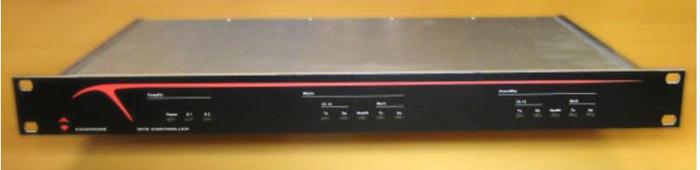

Figure 3‑17 –DSC Modem

### DSC Software

DSC software installed on operator workstation will provide interface to receive and transmit DSC messages.

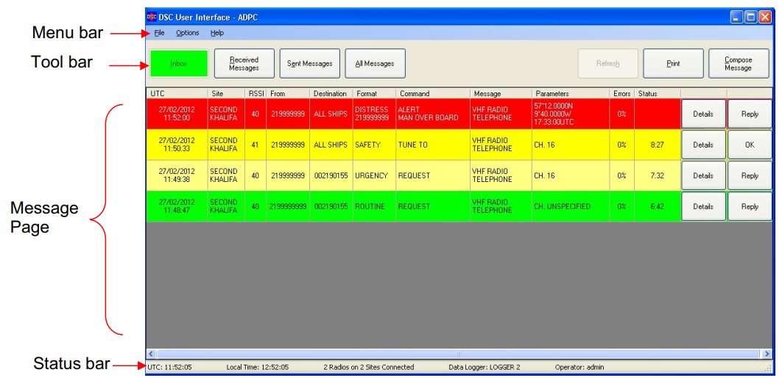

Figure 3‑18 –DSC Software

## RDF Subsystem

The RDF subsystem is represented by RDF antenna and RDF processing software.

### RDF Unit RT-500

The RT-500 operates between 118 and 470 MHz, including COSPAS-SARSAT (CP-SS) and all other V-UHF international distress frequencies. MOB-functionality for crew safety is a standard feature. Extended V-UHF air bands support cooperation with civil and military airborne forces, and the extended UHF FM band covers LMR, PMR and LPD radio frequencies, often used by smugglers and pirates. Scan functions allow creating a scan list, scan all 19 CP-SS channels, or scan multiple SAR frequencies sequentially (CP-SS…121.5…243.0). Additionally, it decodes CP-SS data from an emergency beacon and thereby displays the beacon’s ID, its latitude-longitude location, as well as direction and distance to the beacon.

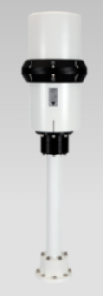

Figure 3‑19 –RDF Unit

The RT-500-M calculates the bearing to an incoming radio signal with an accuracy of 5° RMS. Standard serial, NMEA, and Ethernet interfaces allow integration with ECDIS systems, sharing DF bearing and location data in real time. The installation of the lightweight compact antenna (AU) system requires no RF cables. A distance of 100 m between AU and Display Control Unit (DCU) is no problem.

The RT-500-M direction finding system is ideal for SAR, Coast Guard, and Law Enforcement organizations, easy to install on any size of vessel and practically maintenance free.

All features at glance

• Wide-band radio direction finder‚ 118 to 470 MHz

• Numerous scan functions (COSPAS-SARSAT-Scan, SAR-Scan, Creation of scan lists, Creation of frequency exclude lists, Automatic creation of hit lists)

• MOB function: Saves the current position when pressing the MOB button and then displays the direction and distance to that position.

• High reception sensitivity to permit detection of extremely weak and distant signals

• Designed for use under very rough conditions at sea (IP 67 protection)

• Easy installation, no RF cables required

• Compact wide-band antenna system (Patent DE 4421759 C1)

• 3x NMEA, RS-422 and RS-232 interfaces for system integration and remote control

• DF of all 19 COSPAS-SARSAT channels

• Decode of COSPAS-SARSAT messages

• Storage of several COSPAS-SARSAT messages

• Shows direction and distance to GPS-position of COSPAS-SARSAT beacons

• VHF Air band in 8.33 kHz steps available

• UHF band including frequencies of SRD/LPD and PMR devices (used by pirates and smugglers)

|  |  |
| --- | --- |
| Method of bearing | Doppler-principle (3 kHz rotational frequency) |
| Bearing Indication | Relative bearing and True/ Magnetic bearing (if ext. heading data available) |
| Bearing accuracy | ≤ 5° (RMS) |
| Resolution | 1° |
| Frequency stability | ±2.0 ppm |
| Basic Frequency range | VHF air band: 118.000 to 124.000 MHz VHF marine band: 154.000 to 163.000 MHz (Channel 0 to 88, Sea & Coast) UHF air band: 240.000 to 246.000 MHz Cospas/Sarsat: 400.000 to 406.092 MHz UHF-FM Band: 406.100 to 410,000MHz  Frequency extensions possible see below in Accessories |
| Frequency Options | F1 VHF-Airband: 118.000 – 136.992 MHz F2 VHF-Marineband: 137.000 – 224.995 MHz F3 UHF-Airband: 225.000 – 399.975 MHz F4 UHF-FM Band: 406.100 – 470.000 MHz |
| Channel spacig | VHF Air Band: 8.33 kHz VHF Marine Band: 5/25 kHz UHF Air Band: 25 kHz COSPAS-SARSAT: 8.33 kHz UHF FM-Band: 5 kHz |
| Scanning / Monitoring mode | Monitoring: While normal operating, 4 additional frequencies will be surveilled. (Emergency frequencies 121.500; 243.000 and two free selectable frequencies) Standby: In Standby mode the emergency frequencies, the Cospas/Sarsat and one free selectable frequency is always surveilled. |
| Selectiv Squelch | Trigges an alarm only if a emergency signal is detected. (to avoid fails alarms) |
| Cospas/Sarsat analysis | Reception and analysis of Cospas/Sarsat data signal (112 resp. 144 bit, 400 baud, biphase L-phase modulated, with Bose-Chaudhuri-Hocquenghem error test/ specified according Cospas/Sarsat)C/S T.001 October 1999) Indication of datacontent (mode, country, GPS-coordinates) |
| Bearable modulation types | A3E, F3E, A3X (ELT-modulation) bearing largely independent of modulation |
| Polarisation | Vertical |
| Error of polarisation | ≤ 5° at 60° field vector rotation |
| Time of response | ≤ 50 ms typ. (with sufficient receiving field strength) |
| Keyboard | Foil on the front with integrated keyboard-matrix and EL-background illumination |
| TFT graphic display | 320 x 240 pixel with max brightness of app. 450 cd/m², continuously variable brightness |
| Operating voltage | 12 V to 30 V DC |
| Rated current | 2.5 A |
| Audio | External Speaker 4W (4 Ohm, 8 Ohm ) Line Out (adjustable from 100 mVpp to 2000 mVpp) |
| Data Interfaces | NMEA IBus (RS422 and RS232) Secondary DCU (RJ-45) |
| Weight | DCU: app. 1200 g (2.7 lbs) AU: app. 5200 g (11.7 lbs) |
| Operating temperature | DCU: -20°C to +60°C AU: -40°C to +60°C |
| Ingress Protection | IP 67 |
| Bearing sensitivity VHF Airband | ≤ 4 µV/m / 2,5 µV/m typical at ±5° bearing fluctuation |
| Bearing sensitivity VHF Marineband | ≤ 3 µV/m / 2 µV/m typical at ±5° bearing fluctuation |
| Bearing sensitivity UHF Airband | ≤ 6 µV/m / 4 µV/m typical at ±5° bearing fluctuation |
| Bearing sensitivity COSPAS-SARSAT | ≤ 6 µV/m / 4 µV/m typical at ±5° bearing fluctuation |
| Bearing sensitivity UHF FM-Band | ≤ 6 µV/m / 4 µV/m typical at ±5° bearing fluctuation |

# Dataflow Structure

Wartsila software supply contains many different items, installed in two control centres on different servers. General approach is next: different VTS sensors connects to dedicated software installed on sensor servers (AIS, RDF, CCTV), VTS server gathers all sensor data, processes it and send to Operator workstations.

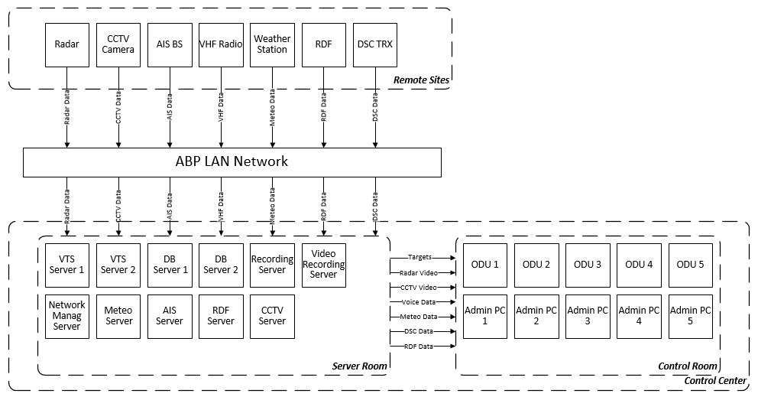

Figure 4‑1 –General Data flow diagram

Radar is connected to radar processor server. There are 2 peace of software installed on radar processor server: ORS server and VARP. ORS server manages radar control and diagnostic. VARP manages radar video. Navi Harbour ODU 0 connects to ORS Server and VARP and distribute control and video to Navi Harbour ODUs installed on Operator workstations

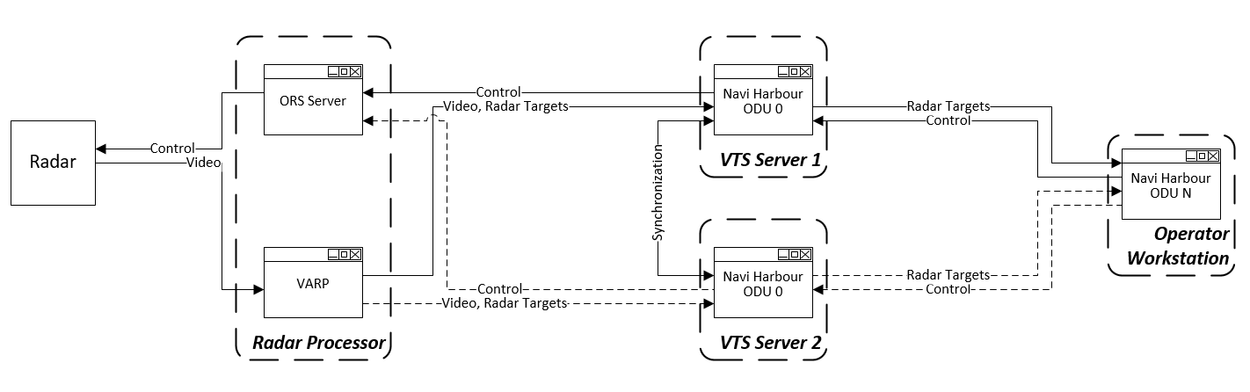

Figure 4‑2 –Radar Data flow diagram

AIS base station is connected to AIS server. There is AIS BSC software installed on AIS server. AIS BSC manages AIS messages and diagnostic. Navi Harbour ODU 0 connects to AIS sever and distribute AIS messages to Navi Harbour ODUs installed on Operator workstations

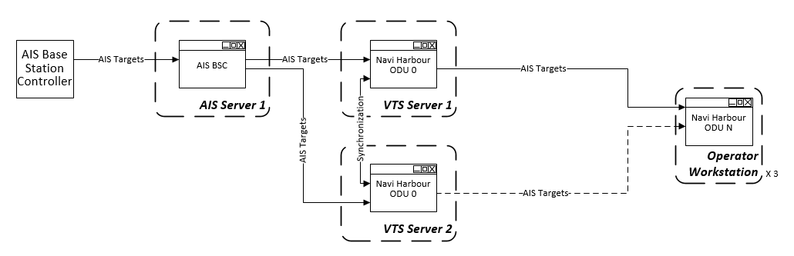

Figure 4‑3 –AIS Data flow diagram

VHF radio stream is connected to Data storage server. There is Voice Recording server installed on Data storage server. Voice Recording server manages reception of VHF radios stream. Navi Harbour ODU 0 connects to Voice Recording Server and distribute audio data to Navi Harbour ODUs installed on Operator workstations.

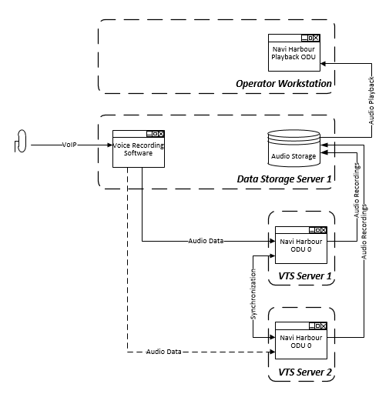

Figure 4‑4 –VHF radio Data flow diagram

CCTV camera is connected to Sensor server for control and to the Video Recording server for video stream. There is CCTV server installed on Sensor Server and CCTV recording software installed on Video recording server. CCTV server manages camera control. CCTV recording software manages video stream recording and distributing. Navi Harbour ODU 0 connects to CCTV Server control to Navi Harbour ODUs installed on Operator workstations. CCTV video recording software distributes online and recorded video to CCTV Viewers.

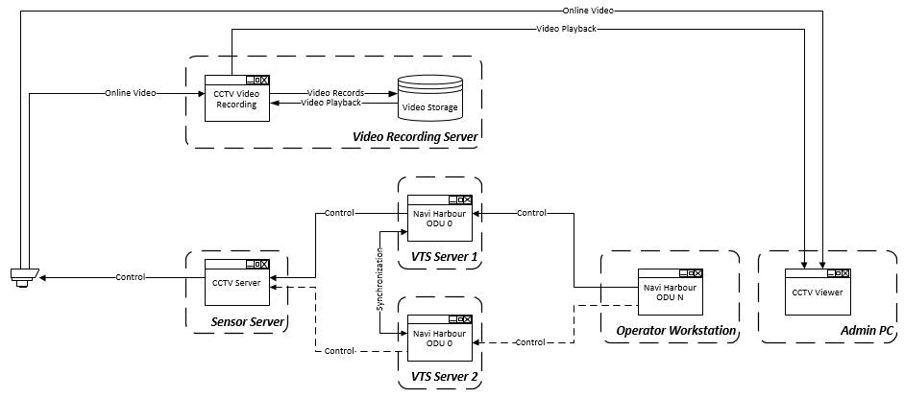

Figure 4‑5 –CCTV Data flow diagram

Weather station data is connected to Sensor server. There is Hydrometeo Server software installed on Sensor server. Hydrometeo Server manages weather messages. Navi Harbour ODU 0 connects to Hydrometeo Server and distribute wheather data to Navi Harbour ODUs installed on Operator workstations

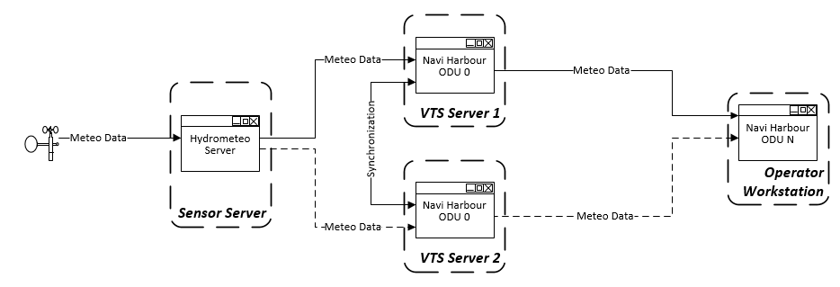

Figure 4‑6 –Weather Data flow diagram

Used port

TCP Ports used in internal data exchange are listed in the table:

|  |  |
| --- | --- |
| **TCP Port** | **Software** |
| 2000 | Navi-Harbour |
| 2000 | Record Server |
| 7500 | CCTV Server |
| 4000 | DF Server |
| 8198 | HM Server |
| 8196 | Global Integrator |
| 8000  8001  8002  8004 | ORS Server |
| 8201 | Sound Server |
| 8040  8042  8044 | AIS BSC |
| 8199 | Target Exchange Server |

### Disaster recovery

All main software components are redundant and have flexible configuration. Two control centers have identical set of servers and can work together or independently.

There are main and backup VTS server in each control center. VTS servers ping each other to check status. In case of main server failure, backup server become active. Configuration is synchronized between all VTS servers in both control centers. Operator workstation connects to active VTS server in own Control center.

There are main and backup Database servers in each control center. There is a replication, made by MS SQL, between all Database servers. VTS servers ping Database servers in own control center to check status. In case of main Database server failure, backup Database server become active.

There are a VTS recording servers in each control center. Active VTS server provide data to own VTS recording server. VTS Workstations get data from VTS recording server in own control center.

Sensors are connected to corresponding sensor server (AIS server, CCTV server, RDF server) in closest control center. In case of sensor server failure sensor application can be launched in other control center manually.

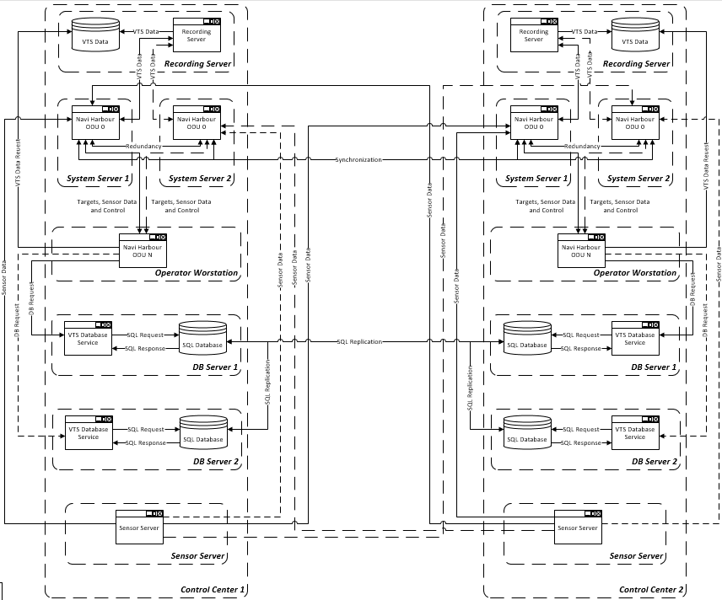

Figure 4‑7 –VTS server redundancy diagram 1

There are one video recording servers in each control center. Servers connect to CCTV cameras to get video stream. Video recording servers work independently. Operator workstations connect to video recording server in own control center.

There is one network monitoring server in each control center. There is a synchronization between servers. Operator workstation connect to network monitoring server in own control center

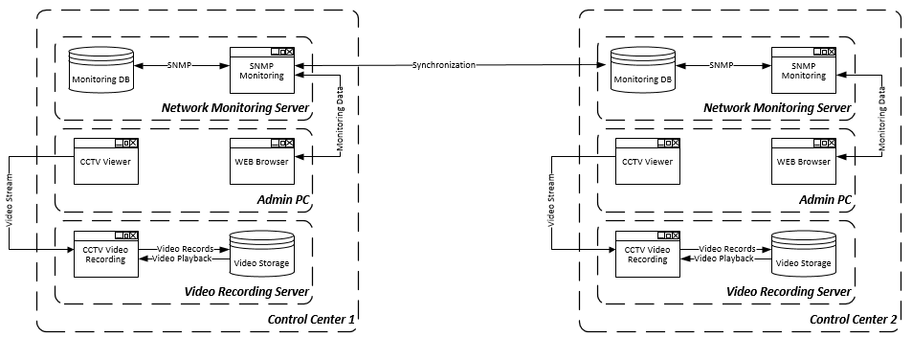

Figure 4‑8 –VTS server redundancy diagram 2

### Bandwidth requirements

There are tables with bandwidth requirement for each site:

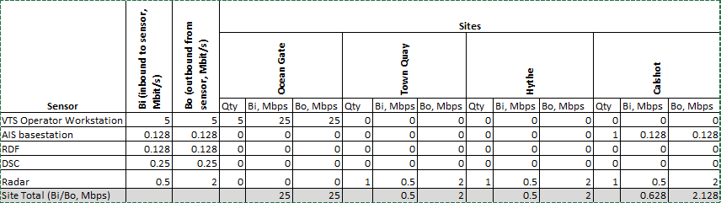

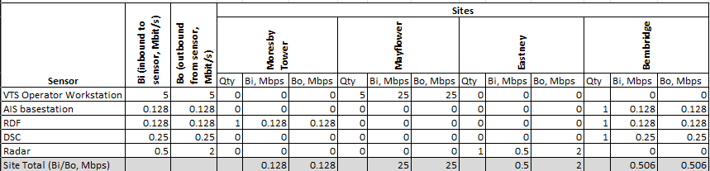

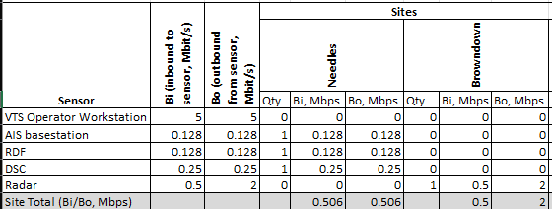

### PMIS integration

VTS shares target data with PMIS. AIS BSC sends AIS stream to PMIS application using NMEA protocol. It is possible to send combined AIS stream from all necessary AIS sources.

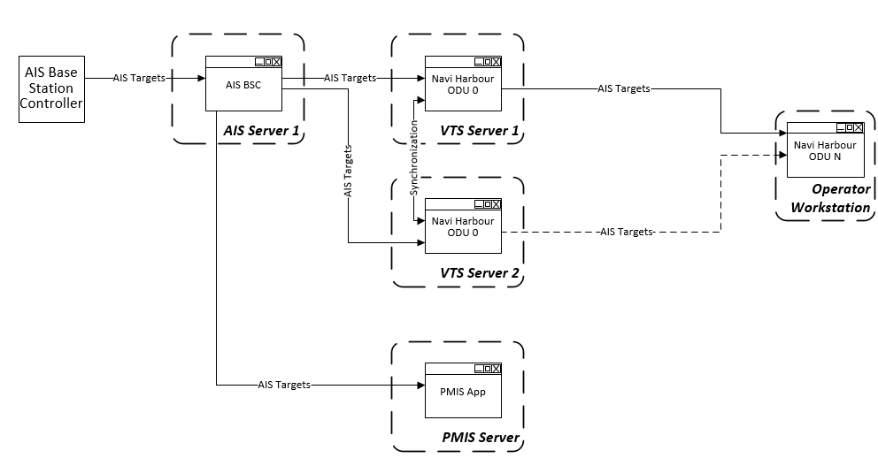

Figure 4‑9 –PMIS Integration

# VTS Processing Core

VTS Processing Core proposed by Wartsila consist of different kind of software.

### VTS Server

Navi Harbour software installed on VTS servers is described in chapter 6.

### Network Monitoring Server Software

Network Monitoring System (NMS) server located in Server Room of Control Tower and has PRTG Software.

PRTG performs the following functions:

* Centralized monitoring/diagnostic of software and hardware components;
* Monitoring equipment room/rack temperature and humidity;
* Watch out an unauthorized access to equipment rack and/or room;
* Monitor system usage (CPU loads, free memory, free disk space etc.);
* Graphical presentation of current component’s status;
* Monitor and account bandwidth and network device usage;
* System events and alarms presentation in tabular form;
* Data log of all system events and alarms in the database with search capability;
* Report generator to create reports in HTML or Portable Document Format (PDF).

PRTG Server component is responsible for monitoring of all components, generation of events and alarms, storing of them in internal SQLite SQL database. PRTG supports two thousand of sensors. Built-in web server with HTTP and HTTPS support is used for client connections.

Sensors are the basic building blocks of PRTG and are organized in an [Object Hierarchy](https://www.paessler.com/manuals/prtg/object_hierarchy). A sensor can tell you about one or more aspects (referred to as [channels](https://www.paessler.com/manuals/prtg/object_hierarchy.htm#channel)) of a device or node. For example:

* Uptime;
* Load;
* Interface throughput;
* Bandwidth usage (for example, flows);
* Loading times;
* Speed;
* Hardware status;
* Temperature;
* Quality;
* Resource consumption;
* User counts;
* Record counts;
* Log events;

The information boxes show how many alarms. Need to click the respective box to view the list of Alarms.



*Figure 5‑1 PRTG Information Box*

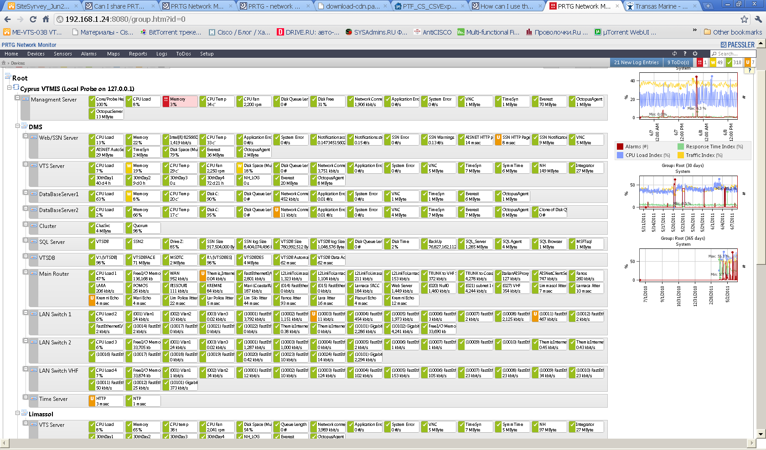

*Figure 5‑2 PRTG sensors list*

All servers, Industrial PCs and Operator PCs have Windows operating system. SNMP and WMI interface are used for monitoring of all PCs and application.

### Milestone Xprotect Product

XProtect Express is manageable, affordable IP video management software (VMS) for companies requiring a security solution with functionality beyond typical video surveillance capabilities. It is built with innovative technology designed to save you money and boost the overall performance of your hardware. With full alarm management capabilities and multi-layered map XProtect Express is suited for business with light live monitoring needs. It can manage up to 48 surveillance cameras and supports simple ways of incorporating video into existing business operations, such as linking access control to live video feeds.



Figure 5‑3 Distributed System Setup

### Milestone Xprotect Smart Client

Designed for Milestone XProtect® IP video management software, the XProtect Smart Client is an easy-to-use client application that provides intuitive control over security installations. Manage security installations with XProtect Smart Client which gives users access to live and recorded video, instant control of cameras and connected security devices, and an overview of recordings. Available in multiple local languages, XProtect Smart Client has an adaptable user interface that can be optimized for individual operators’ tasks and adjusted according to specific skills and authority levels.

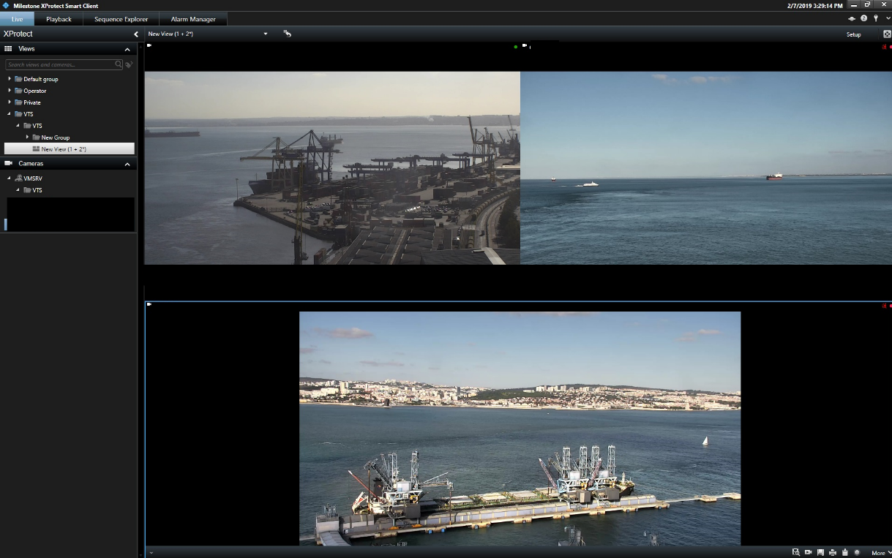

Figure 5‑4 Xprotect Smart Client Interface

### Database server

VTS Database SW provides extensive capabilities for managing and storing different types of data related to ships, ship visits and port activities in the tabular form:

* Input, storage and editing of data on new VTS information objects;
* Automatic input of information on AIS equipped vessels in the database;
* Automatic recording of ship visits data;
* Automatic recording of ship position in the VTS area;
* Referencing to scheduled visits;
* Use of database information for identifying acquired radar targets;
* Generation of Vessel Positioning report for a certain moment of time;
* Processing of information and display of data selected according to the parameters set by the operator;
* Easy-to-use and intuitive interface.

### Configuration

VTS Database SW consists of VTS Database Service components installed on VTS Database Server and several VTS Database Client Terminal. VTS Database Client Terminals are installed on Operator Workstations to provide access to VTS Database.

VTS Database consists of reference books. Reference book is a table in Database which contains data logically related to each other. The table row is called a Record of the reference book. Each table column called field has a name unique for this table. All the values in the columns are of the same type.

Database consists of several mutually related reference books. Contents of one reference book are used for filling in other reference books.

The VTS database has following base reference books:

* Vessels
* Visits
* Operations
* Log book
* Positioning
* Incidents
* Weather log

As these reference books are filled in, auxiliary reference books whose contents are displayed in the drop-down lists of fields with the same name are used:

* Companies
* Personnel
* Positions
* Meteo stations
* Regions
* Ports
* Flags
* Cargoes
* Vessel types
* Target Classes
* Company types
* Occupations
* Vessels in Incidents.

The names and field types of auxiliary reference books of VTS Database may be different for each particular database because database is created individually for the customer’s requirements **(including classification societies, ship owners and agents)**.

Example of Database window is presented on the figure below.

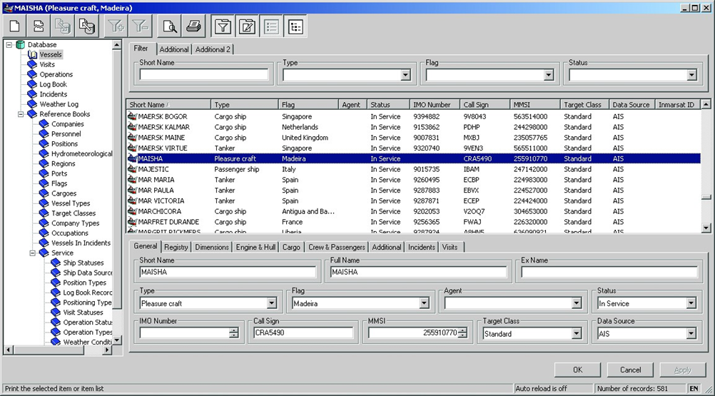

Figure 5‑5 Database Window

### Database Filling

After a new AIS target has been acquired, a search for the ship with the same MMSI number is made in the database:

* if the ship is found, this ship data is associated with the target;
* if the ship is not found, an entry can be added to the database and associated with the target. The following fields are filled in:
* Name and short name;
* MMSI;
* Call sign;
* INO number;
* Length, width, draught;
* Authenticity – “No”.

### Import Utility

There is a way to import data from any source having full information about imported data (format, Data Type, date, time etc). Example of VTS DB Exchange Service Utility is presented below.

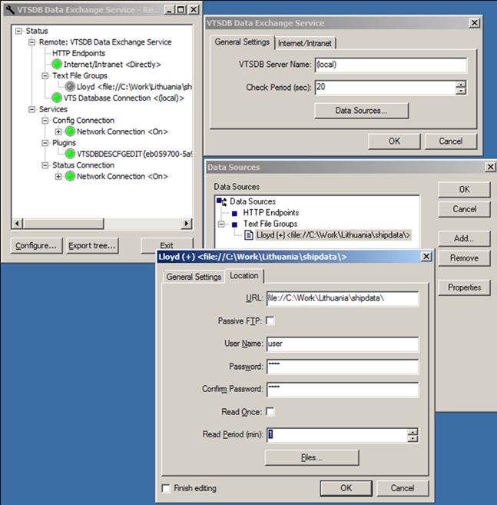

Figure 5‑6 Database Exchange Service Utility

### Handling Database Data

In the work with databases, the following operations are available to the operator:

* Adding, editing and deleting records
* Selecting information by criteria
* Sorting records
* Viewing and printing out reference books in the form of a table
* Creating ship position report.

Special tool allows operator to get vessel information from database. The tool allows opening the database window with information on the target selected with the cursor in the Chart window. The screen will display the database window with information on the selected target.

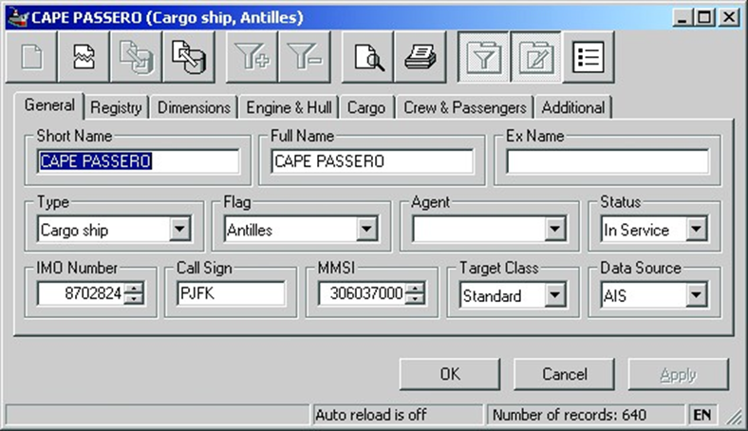

Figure 5‑7 Database window

## Time Synchronization Subsystem

### Time Server

The LANTIME (Local Area Network Time Server) provides a high precision time base to a TCP/IP network (Stratum-1-Server). The NTP (Network Time Protocol) is used to synchronize all NTP clients with the reference. The several LANTIME variants differ from each other by the time reference and output configuration. A GPS or GNSS (GPS, GLONASS, Galileo, BeiDou) receiver, GNS-UC (only GPS and Galileo), a long wave receiver (like DCF77, MSF or WWVB) or an IRIG time code receiver can be integrated as an internal reference as well as a combination of these references (hybrid system). External references are also possible.

The LANTIME system is a set of equipment composed of an integrated GPS receiver, a single-board computer and a power supply, all installed in a metal 19-inch modular chassis and ready to operate. A simplified

LINUX operating system is installed on the single-board computers flash disk. Eight push buttons and a display can be used to configure and monitor the time server.

After the network connection has been established the time server can also be configured and monitored remotely from a workstation via TELNET or FTP. An integrated web server enables access to the LANTIME by using an ordinary web browser. 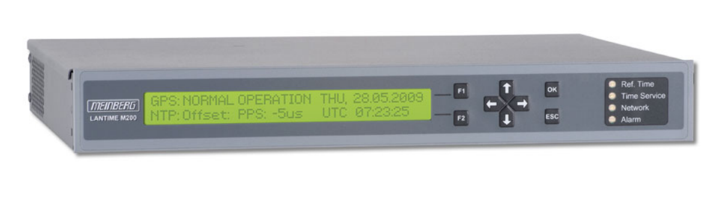

*Figure 5‑8 Time Server Meinberg Lantime M200*

|  |  |
| --- | --- |
| Characteristics | Description |
| Display | LC-display, 2 x 40 characters, with backlight |
| Control elements | Eight push buttons to set up basic network parameters and to change receiver settings |
| Status info | Four bicolor LEDs showing status of:  - reference time  - time service  - network  - alarm |
| Network Interface | RJ-45 Network Connection 10/100 MBit |
| Universal Serial Bus (USB) Ports | 1x USB Port in rear panel:  - install firmware upgrades  - backup and restore configuration files  - copy security keys  - lock/unlock front keys |
| Power supply | Standard: 100-240 V AC (50/60 Hz)  available DC variants: 100-200 V DC, 12 V DC and 20-60 V DC |
| Power consumption | 20W |
| CPU | AMD Geode |
| Operating System of the SBC | Linux with nano kernel (incl. PPSkit) |
| Network protocols OSI Layer 4 (transport layer) | TCP, UDP |
| Network protocols OSI Layer 7 (application layer) | TELNET, FTP, SSH (incl. SFTP, SCP), HTTP, HTTPS, SYSLOG, SNMP |
| Internet Protocol (IP) | IP v4, IP v6 |
| Network Time Protocol (NTP) | NTP v2 (RFC 1119), NTP v3 (RFC 1305), NTP v4 (RFC 5905) SNTP v3 (RFC 1769), SNTP v4 (RFC 4330) MD5 / SHA-1 Authentication and Autokey Key Management |
| Time Protocol (TIME) | Time Protocol (RFC 868) |
| Daytime Protocol (DAYTIME) | Daytime Protocol (RFC 867) |
| IEC 61850 | Synchronization of IEC 61850 compliant devices by using SNTP |
| Hypertext Transfer Protocol (HTTP) | HTTP/HTTPS (RC 2616) |
| Secure Shell (SSH) | SSH v1.3, SSH v1.5, SSH v2 (OpenSSH) |
| Telnet | Telnet (RFC 854-RFC 861) |
| Form Factor | 335 x 45 x 240 mm |
| Ambient temperature | 0 ... 50°C / 32 ... 122°F |
| Humidity | Max. 85% |

### SymmTime SW

SymmTime is a desktop clock. It allows to make synchronize the system clock with the Time server LANTIME M200.

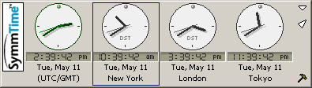

*Figure 5‑9 SymmTime Application*

It allows you to choose when and how often you want to have the time synchronized and what synchronization servers to use. It even lets you view a detailed report of the synchronization status. Additionally, the app allows you to view the time in any timezone and it can be set to display multiple clocks.

If you right-click on a clock in your SymmTime panel, this menu displays. The menu options are detailed here.

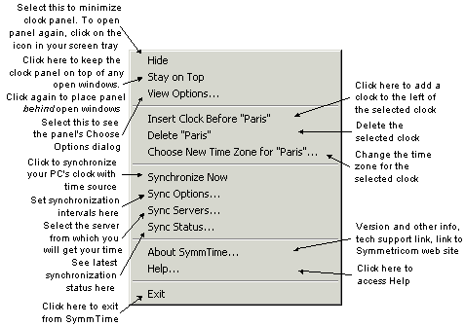

*Figure 5‑10 SymmTime Menu*

This option on the right-click menu tells your SymmTime when to synchronize (at selected intervals) with the server, and what the maximum adjustment threshold should be. Also, you can direct SymmTime to retry syncing if at first there is no response.

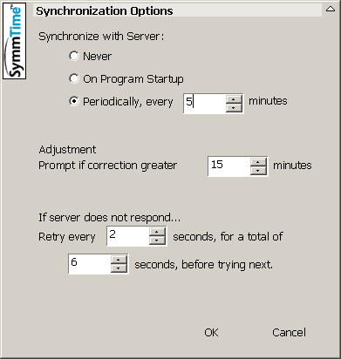

*Figure 5‑11 Sync Options*

This option on the right-click menu lets you see the servers your SymmTime is actively using, as well as unused servers that you can add to your active list.

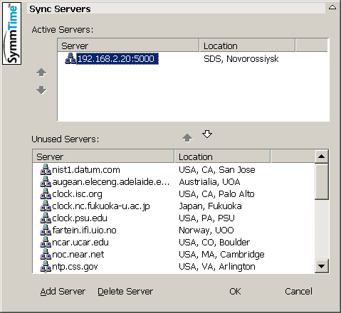

*Figure 5‑12 Sync Servers*

This option on the right-click menu shows you the time of the last synchronization and the next along with recent history.

### TIMESERVER application and TIMESYNCCLIENT service

For the organization of all servers, computers and electronic devices time synchronization is used synchronizing component from the Navi-Harbour software package, which includes **TIMESYNCSERVER** and **TIMESYNCCLIENT** software.

**TIMESYNCSERVER** application installed on VTS Server virtual machine. **TIMESYNCSERVER** uses VTS Server system clock as a source of the accurate time for time synchronization.

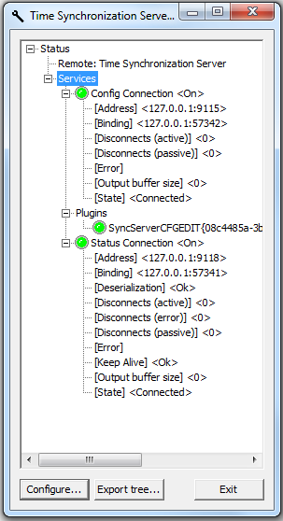

*Figure 5‑13 Time synchronization server*

**TIMESYNCSERVER** program run with the following parameters:

|  |  |  |
| --- | --- | --- |
| **Parameter type** | **Description** | **Default value** |
| <name>.ini | Name of ini file in use | SyncServ.ini |
| /x | Use IPX protocol | Use TCP protocol |
| /s<socket number> | IP port number which does not conflict other IP port numbers used in this computer | 5000 |
| /p<number> | Period of sending synchronized messages | 10 sec |

**TIMESYNCCLIENT** service (**SyncClient**) installed on each server, virtual server and computer in VTMIS system except VTS Server 1 and 2. **TIMESYNCCLIENT** service (**SyncClient**) uses **TIMESYNCSERVER** application installed on VTS Server 1 and 2 as a source of accurate time for time synchronization.

To make sure the TIMESYNCCLIENT service program installed properly and running in the following way, it is necessary:

Open Task Manager by right-clicking the taskbar, and then clicking **Start Task Manager**.

Click the **Services** tab to see a list of all the services that are currently running on your computer and find TIMESYNCCLIENT service by name **SyncClient.**

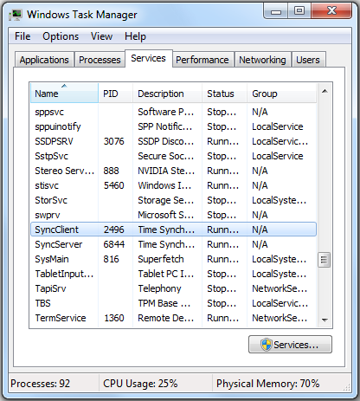

*Figure 5‑14 Time synchronization client*

# Software VTS. Navi-Harbour

The solution proposed herein is based on Wartsila Navi-Harbour SW which is designed for Vessel Traffic Management Systems (VTMS). Navi-Harbour has numerous installations in world’s busiest ports, thus it is designed to fulfil operational requirements in ports with sophisticated navigational situation.

## Operating Principles

The operating principle consists in:

* reception of information on the navigational situation from the external sources referred to as SENSORS;
* generalizing of the target data;
* presentation of the target data in the Target Table;
* presentation of graphic target data in combination with the multi-layer electronic charts of the area;
* analysis of the navigational situation and generation of alarms and warnings according to the criteria set by the operator;
* output of various auxiliary navigational and other information;
* digital recording of the navigational situation data for the further playback.

For security purposes, the accessibility of the system will be developed by following hierarchy architecture, segregated by the use of passwords (In precedence order):

* VTMS Operation level (Disabled: Chart editing; Access level editing; Parameters of VTS sensors connection; Navigational zones adding, changing or deleting; Default alarms settings; Logging control)
* VTMS Supervisor level
* VTMS Management Level
* Any number of levels with any restrictions can be created

## System Interface

### Operators and Security lists.

Navi-Harbour uses local data base to store list of users and security levels. Security levels are not associated with specific operators. Operators and security levels are protected with passwords. Any operator can change own security level to perform some advanced actions. It is recommended to use minimal security level for daily activities.

List of default permissions is shown in the table:

|  |  |  |  |
| --- | --- | --- | --- |
| **Operation** | **Administrator** | **System engineer** | **Operator** |
| VTS chart editing | Yes | Yes | – |
| Sensor chart editing | Yes | Yes | – |
| Nautical chart editing | Yes | Yes | – |
| User chart editing | Yes | Yes | – |
| ODU configuration | Yes | Yes | – |
| Sensor configuration | Yes | Yes | – |
| Network configuration | Yes | Yes | – |
| Default alarm setting | Yes | Yes | – |
| List of operators | Yes | Yes | – |
| VTS operation modes | Yes | Yes | – |
| System security parameters | Yes | – | – |
| Logging control | Yes | – | – |
| Closing of VTS Server program | Yes | Yes | – |
| Closing of VTS Client program | Yes | Yes | Yes |
| Sensor control. Radar control – general | Yes | Yes | Yes |
| Sensor control. Radar control – advanced | Yes | Yes | – |
| Sensor control. CCTV control – general | Yes | Yes | Yes |
| Sensor control. CCTV control – advanced | Yes | Yes | – |
| Sensor control. RDF control – general | Yes | Yes | Yes |
| Sensor control. RDF control – advanced | Yes | Yes | – |
| Changing of chart settings | Yes | Yes | – |
| Changing of message options | Yes | Yes | – |
| VTS Server selection | Yes | Yes | – |
| Setup system status messages | Yes | – | – |
| Worksapace control – general | Yes | Yes | Yes |
| Worksapace control – advanced | Yes | Yes | – |
| Worksapace control – save as default | Yes | – | – |
| Target symbol presets editing | Yes | Yes | – |
| Changing of target classes configuration | Yes | Yes | – |
| Target identification | Yes | Yes | Yes |
| Target classification | Yes | Yes | Yes |
| Target dropping | Yes | Yes | Yes |
| Database operations | Yes | Yes | Yes |

It is possible to access any settings of ODU 0 from any ODU N.

### General Description of System Interface

Graphical interface of the system is based on Windows technology.

There are following basic elements of the interface:

Entire operator activities are accessible via system menu. All information tables also have context menus. All menus can be customized by system operator.

Most useful operations are accessible with single click buttons grouped in toolbars corresponding to its application. Buttons on toolbars can be customized by operator. Following toolbars are available. Following toolbars are available in the default configuration:

* Chart operations.
* Base chart editor.
* Chart editor.
* Extended chart editor operations.
* Target information.
* Target tracking.
* Target prediction/simulation.

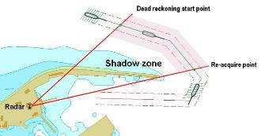

Figure 6‑1 Target prediction

* Logging.
* Database operations.
* CCTV cameras control.

Multiple Chart Windows can be displayed on Operator Display Unit (ODU) monitors with possibility to select size, position and displayed area for each of them.

Specific data is distributed in a set of information tables:

* Tracked target table.
* Buoy targets table.
* Fixed targets table.
* Navigational alarms table.
* Hardware alarms table.
* Target pair table.
* Aids-to-Navigation table.
* AIS target table.
* Target search table.

Special data panels are displaying numeric navigational information:

* Cursor data panel.
* Date and Time panel.
* Reference target data panel.
* Route data panel.
* CPA\TCPA data panel.

System diagnostics panel is displaying on-line diagnostics for system main components and connected sensors.

Hot-key combinations are assigned to most operations.

ODU execute also the following functions:

* Presentation of digitalised geographical map/chart as underlay in the main display, and overlapping the combined radar video / track on it;
* Presentation of target tracks from Radar as well as UAIS;
* Generation of complete situational awareness picture of the area of interest, to enable surveillance and monitoring;
* Generation of automatic alarm when targets cross pre-set alarm criteria or a predefined surveillance area set on the display;
* Remote control of individual radar parameters;
* Database management of targets/tracks;
* ‘Multi sensor data fusion’ allowing correlation of data from both the radars as well as UAIS.

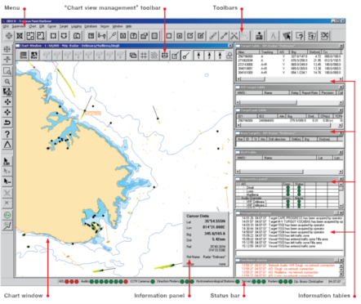

Figure 6‑2 Navi-Harbour Main Window

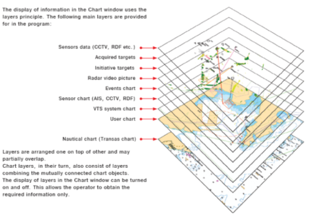

Figure 6‑3 Navi-Harbour Chart Layers

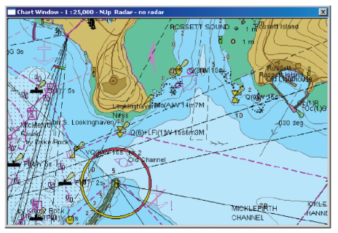

Figure 6‑4 Navi-Harbour Chart Window

Dedicated VTS operator keyboard provides one touch access to major operator activities.

### Chart Window

General Description

Operator can create one or several (up to 8) independent Chart Windows. Each Chart Window displays following set of information in VTS area:

* Navigational charts.
* System charts.
* Tracked targets.
* Radar video overlay.
* Other visual information.

Operator can save, close, rename, resize any Chart Window or move it to particular place on the desktop.

Supported Navigational Charts

The following navigational chart formats are supported:

Vector TX-97 chart format. TX-97 vector data (TX-97 format charts) are produced according to Wartsila standard. The production of TX-97 data is organized according to ISO 9001 product quality management standard.

S-57 electronic charts (IHO S-52 standard presentation) converted to internal .cd8 format using Chart Assistant utility.

GeoTIFF files (i.e. satellite images).

ERSI Shapefile (i.e. data from Geodetic Informational Systems).

All supported charts are storing in VTS-server and distributing to each ODU of the system.

Electronic chart includes following objects:

* Coastline.
* Land objects.
* Depth contours.
* Depths.
* Buoys.
* Lights.
* Warning points.
* Caution areas.
* Anchorage areas.
* Traffic separation schemes etc.

Target Data Presentation

System provides continuous monitoring of all tracked targets' positions, vectors and displays this data on the electronic chart. Operator can choose following options for targets displaying:

* Selectable target symbol (dot\scalable\bitmap).
* Special target symbol for target tracked by AIS, radar or AIS+radar data.
* Target text data (ID, course, speed, heading, AIS report rate) with adjustable position relatively to target symbol.
* Target vector with adjustable length.
* Target history with selectable length, type of history line and time marks.
* Graphical AIS data presentation (heading, vessel dimensions, GNSS antenna position, rate of turn).
* Vessel outline based on real dimensions (if available).
* Possibility to assign different target symbols to particular vessel types.
* Vessel safety domain.



Figure 6‑5 Targets



Figure 6‑6 Legend



Figure 6‑7 Target Direction

Radar Video Picture Presentation Over Electronic Charts

System provides to operator presentation of multi-radar video picture over electronic charts. Operator can choose following options to display this picture:

* Possibility to select the radars for simultaneous presentation of video picture or mosaic radar picture.
* Possibility to select transparent radar video presentation with selectable density level (25% - 100%).
* Radar video afterglow presentation with color fading. Adjusted afterglow length (from 0 to 400 scans or unlimited).
* Selectable scan-scan correlation for video presentation.
* Highlighting of persistent target functionality to improve visibility of echoes from small targets.
* Multi-radar video picture presentation can be displayed in overlapping or mosaic mode.
* Fill gaps mode (sweep-sweep approximation).
* Suppression of shore radar echo (video masking zones).
* Possibility to change default radar video presentation colors. This functionality is available on request.



Figure 6‑8 Target Display Options





Figure 6‑9 Radar Video Presentation

### Information Tables

Informational tables contain text data about particular types of system objects. All tables can be adjusted by size, number and width of columns. Operator can choose column to sort data in preferred order. Tables can be switched to “Always on top” mode above of the Chart Windows. Each table has own context menu and provide fast access to most operations. Tables can be printed.

Target Table

Target table contains data about all targets acquired by system (manually by operator or automatically). Operator can locate target in a table using special search panel. Target table has additional optional “Selected target info” panel.



Figure 6‑10 Target Table

AIS Target Table

AIS target table contains all AIS targets in a system coverage area (including SAR aircrafts) even if they aren’t acquired. Operator can locate target in a table using special search panel.



Figure 6‑11 AIS Target Table

Fixed Target Table

Fixed targets table contains information about radar fixed targets. This data can be used for radar calibration procedures



Figure 6‑12 Fixed Target Table

Aids-to-Navigation table

Aids-to-Navigation table contains information about A-to-N object equipped by AIS in a coverage area.



Figure 6‑13 Aids-to-Navigation Table

Navigational alarms table

Navigational alarms table stores list of navigational alarms.



Figure 6‑14 Navigational alarm Table

Hardware alarms table

Hardware alarms table stores list of sensor alarms are below:



Figure 6‑15 Hardware alarms Table

Target Pair Table

Targets with CPA/TCPA alarms are automatically adding to Targets pair table. Also, operator can manually add any number of targets pairs for continuous monitoring their relative position. Targets can be easily removed from this table if necessary.





Figure 6‑16 Targets pair table

Target Search Table

Operator can determine one or several criteria. Targets comply with these criteria will be added to this table. Operator can switch on continuous highlight mode for these targets.

### Data panels

Data panels provide to operator set of numeric data. There are following data panels available:

**Cursor data:** continuously display of geographic coordinates and relative position of cursor in a chart window.



**Reference target:** can be opened for selected target. This panel displays coordinates, course and speed of this target. For each Chart Window operator can open one panel.



**CPA/TCPA:** can be opened for selected target, if another target was chosen as reference. This panel displays CPA/TCPA for selected pair of targets.



**Route:** can be opened for selected routed target. This panel displays DTE, XTE and other route parameters.



### System diagnostic

System provides to operator diagnostic of main components and sensors. Short diagnostic is located in a status bar.



Advanced diagnostic can be checked in a special diagnostic panel. All critical events in this panel appear as alarms in hardware alarms table.



Figure 6‑17 System Diagnostic Panel

## Basic chart operations

### System diagnostic

The following chart operations are available in a Chart Window:

* Any set of licensed charts can be displayed for each Chart Window independently (loading/unloading through the operator toolkit).
* User-defined set of chart overlays is adjustable for each Chart Window independently.
* Smooth scaling, arbitrary off-centering and electronic chart alignment (60 selectable scales from 1:1000 to 1:1000000000).
* Rotation of the area’s chart display.
* Multi-step undo of previous changes of scale, off-centering etc.
* Fast zoom to any selectable area inside of Chart Window.
* Instant Zoom facility with adjustable zoom ratio and size of zoom area.
* Constant Zoom of some particular area or vessel (with “follow” function) in a separate adjustable window.
* General View window for fast navigation inside of responsibility area.
* Operator can choose between 4 different palettes (Day, Twilight, Dusk, and Night), depend on work conditions. These palettes include colors of objects in a Chart Windows, targets, radar video, text in tables and background.



Figure 6‑18 Color Patterns

* Wide variety of screen focusing on desired area (focusing on the target, buoy, group of targets etc.).
* System allows operator to choose between unlimited numbers of predefined reference points or select any geographic position as a reference point using corresponding tool.
* Displaying of coordinates grid.
* Displaying of range rings centered on operator defined point (reference point).
* Electronic range and bearing line (ERBL). Operator can choose different ERBL modes: floating and fixed tooltip, different measurements unit, scalable measurements units (unit depends on measurement distance).
* Fast switching between observe areas using “predefined area” tool.
* Displaying information about any chart object.
* Printing any Chart Window or information table with several print modes.
* Selecting of measurement units incl. imperial units (NM, cables, km, m, feet, yards, knots, km/h, m/s etc).
* Selecting date/time format.

## Target operations

### Basic target operations

The following set of tools allows working with targets:

* Automatic target acquisition (any set of predefined polygonal auto-acquisition zones).
* Manual target acquisition.
* Target identification (entering static vessel data) manually or attaching to the VTS DB entry.
* Displaying full set of target’s information in a special panel.
* Automatic target identification for AIS targets.
* Target auto drop facility.
* Manual target drop.
* “Follow” tool for target of special interest.
* Reference target tool for continuous monitoring of target’s dynamic data.
* CPA\TCPA on-line calculation for any targets pair.
* ETA table for all targets approaching selected arbitrary point.
* ERBL tool attached to moving target with course angle displaying.
* Target identification data exchange tool for swapped targets.
* Target pair merging tool for lost target reacquiring.
* Destination point tool: possibility to select for every target the arbitrary destination point and continuously monitor the approaching parameters (distance, course deviation, ETA etc.).
* “Dangerous cargo” status can be assigned to the target and allows operator to highlight targets with dangerous cargo or hazard materials on board.
* “Service ship” status can be assigned to the target and allows operator to avoid alarms from port tugs, pilot boats and other service vessels in VTS area.

### Target tracking modes

There are four target tracking modes: free, routed, anchored and moored.

**Free mode:** is a standard tracking mode, assigned to all acquired targets.



Figure 6‑19 Free mode

**Anchored mode:** is assigning to target at anchor. In this mode system will monitor position of target and anchor domain around it with generation of anchored alarms. This mode can be assigned manually by operator or automatically from AIS status.



Figure 6‑20 Anchored mode

**Routed mode:** is assigning to target moving on a predefined route.





Figure 6‑21 Routed mode

Traffic routes can be created in the system with following parameters:

* Allowed traffic directions.
* Speed limits on route.
* Safety domain radius for route vessels.
* Channel edges and depth.
* Allowed deviation (XTE and DTE).
* Autoroute parameters.

Target can be assigned to route manually (by operator) and automatically (autoroute function). System provide to operator following functions for routed targets:

* Calculation of XTE and DTE for all routed targets with generation of alarm if XTE or DTE is dangerous for target safety passage.
* Monitor target course and speed with generation of alarm in case of parameters violation.
* Display target ETA schedule for all route reference points.
* Display route reference point ETA schedule for all passing targets.

Operator can use Route Profile – sophisticated route planning tool. It provides following advantages:

* Graphical display of all targets along the route in range/time co-ordinates.
* Calculation and easy modeling of targets’ related movement.
* Specific route segments support (meeting prohibited, route reference point, etc.)

**Moored mode:** is assigning to moored target. This mode allows operator to plan mooring operations. Target can be moored to predefined berths. This mode can be assigned manually by operator or automatically from AIS status (in this case system will choose closest berth to target’s position).



Figure 6‑22 Moored mode

### AIS data handling

When the system equipped with one or several AIS data source the following ODU functionality is provided:

* Displaying of Class A and Class B AIS targets.
* Auto identification of the target with AIS data.
* AIS + radar target data integration with possibility to choose type of data used for tracking (AIS, radar or AIS+radar).
* Displaying static vessel information received from AIS source.
* Interrogation (manual), receiving, processing and displaying of AIS extended static information sent using Binary Messages according to IMO Circular SN236:
* Number of persons onboard.
* Dangerous cargo information.
* Air draught.
* Auto identification of AIS data with VTS database record.
* Sending\Receiving of safety-related and text AIS messages.
* AIS target report rate control.
* Automatic changing of tracking mode (free, anchored) from AIS data.
* Automatic changing Dangerous Cargo status from AIS data.
* Displaying of Search and Rescue Aircrafts with special symbol.
* Displaying of Aids-to-Navigation objects with special symbol.

### AIS services

Man-Over-Board (MOB) over AIS service

This feature allows reception of MOB bearings from Wartsila Navi-Sailor over binary AIS messages. Several ships equipped by RDF sensors and AIS-transponders receive signal from MOB beacon and transfer it to coastal station. Operator can locate estimated position of the beacon if at least 2 bearings are available. System generates alarm if beacon appeared. This complex solution allows locating overboard person and organizing SAR operation.

### Prediction and simulation

Additional set of target management tools allows operator several advanced functions:

* Target position prediction provides calculation of all targets positions according to the current target’s mode (en-route calculation for the targets assigned to the route) for unlimited time ahead using the mouse.
* Trial Maneuver tool allows operator to simulate changing speed or course of two targets to avoid collision between them.



Figure 6‑23 Trial Maneuver tool

* Destination point allows operator continuously view course angle and ETA from selected target to any geographic point.



Figure 6‑24 Destination point

* Operator can create simulated targets by setting of position, course and speed.
* For every created simulated target operator can change position, course and speed or drop it.





Figure 6‑25 Changes of simulated target

### Navigational alarms



Figure 6‑26 Navigational alarms

System has set of navigational alarms intended to avoid accidents in coverage area.

All alarms appear in the Navigational alarms table and attended by audible alert.

Alarmed targets also indicated in a Chart Windows and target table. Operator should acknowledge alarm to switch off sound alert. For each particular type of alarm is possible to change alarm criteria, alarm sound and priority. There are 4 priorities supporting to operator in decision of the alarm importance. Alarm sound can be selected from 3 predefined sounds. Operator can load additional sound files in a standard .wav format and use them in alarms generation.

Operator has the possibility to attach individual alarm setting to any target or group of targets.

To avoid unnecessary alarms from port tugs, pilot boats and other service vessels, operator can assign to corresponding targets the “Service ship” status.

The following list of alarms is available in a system.

**Standard alarms:**

* CPA/TCPA
* Safety domain breach, free mode collision danger
* Lost on sensor
* Target acquired
* Target dropped

**Alarms for routed targets:**

* XTE out on route
* Dangerous DTE
* Collision danger, meeting on route
* Collision danger, meeting on turn point
* Collision danger, overtaking on route
* Grounding on route
* Course out of route
* Speed limit breach on route
* Enter/leave route line
* Approaching to turn point

**Alarms for anchored targets:**

* Anchor dragging
* Anchor domain violation

**Alarms for AIS targets:**

* Low position accuracy
* Navigational status changed
* Tracking mode has been changed
* Incoming AIS message (safety related)
* Incoming AIS message (binary)

**Alarms for buoys, A-to-Ns and fixed targets:**

* Buoy off-position
* Buoy lost
* Fixed target dangerous drift
* Fixed target off-position
* A-to-N off-position
* A-to-N low position accuracy

**Traffic zone alarms (number of zones does not limited):**

* Speed limit
* Target decrease speed
* Target increase speed
* Suspect anchoring
* Restricted course
* Transit time violation
* Number of targets in zone exceed limit
* Sudden turn

**Guard zone alarms (number of zones does not limit):**

* Approach to zone border outside
* Approach to zone border inside
* Entering zone
* Leaving zone
* Being in zone
* Reporting line crossing

### Hardware alarms

System provides to operator diagnostic of main components and sensors. All critical events appear as alarms in hardware alarms table. Operator can mask any unwanted alarm.

### Automatic sending of AIS messages

System provides possibility to send automatically safety related AIS message to ship than it is crossing predefined reporting line.

## CCTV Sensor Operations

### Focusing on objects

Operator can focus on targets or any chart objects.

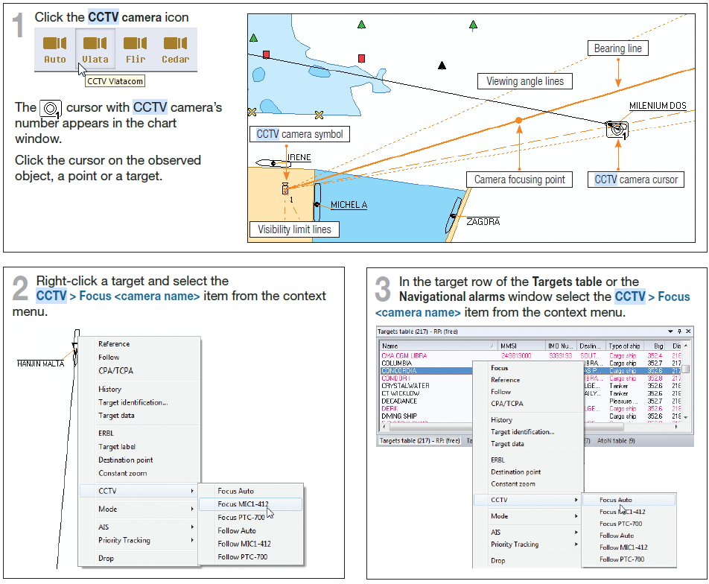

Figure 6‑27 Focusing on target procedure and graphic presentation

### Automatic following

Operator can lock the camera on target.

The CCTV camera symbol and the observed object will be connected with a dashed orange coloured line, and the CCTV camera will be turning automatically until this line is coincident with the CCTV camera’s bearing line which is plotted on the chart as a solid orange line.

The camera’s viewing angle lines are shown in small dashes, and the camera’s visibility limits - in a dash-and-dot line.

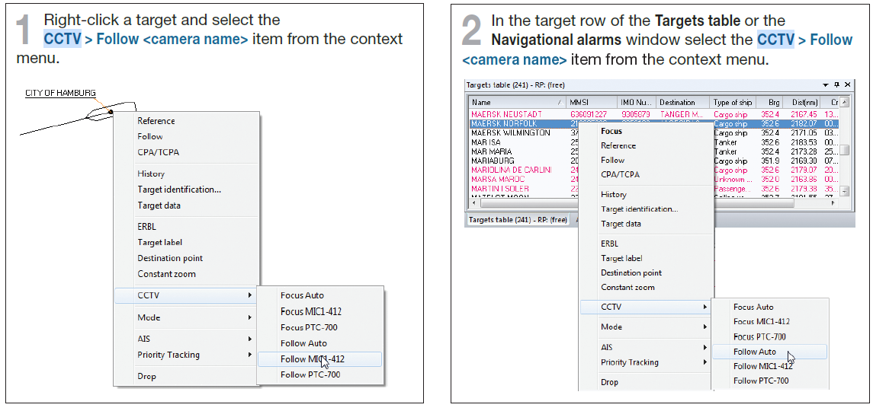

Figure 6‑28 Follow procedure

The CCTV camera will be turning automatically keeping the target inside the angle of view.

When the Following Auto mode or the icon is selected but there is no free CCTV camera in the responsibility zone at this moment, then following of the target will start when

* Any camera is released in the responsibility zone
* The target moves to another responsibility zone.

To cancel the follow mode, do either of the following:

1. Click the icon of the CCTV camera which followed the target.

2. Clear the check mark in the target context menu or in the table context menu.

* The follow mode is cancelled automatically in the following cases:
* In the CCTV Cameras control window, the pan or tilt angle has been changed
* The target has been dropped or lost
* Another ODU has taken over the CCTV camera control.

### Auxiliary

#### CCTV Camera Control Window

To open the CCTV Cameras control window:

ff Choose the Sensor > CCTV Cameras menu item. The CCTV Cameras - <camera name> window opens up.

The window title bar shows the name of the CCTV camera selected in the tree view in the left part of the window, and the name of the target tracking or focusing-on-target operation if any is currently performed by the CCTV camera.

* The pairs of fields show the CCTV camera pan and tilt angles, zoom and focus:
* The left hand field shows the current parameter value
* The right hand field – a value, set by the operator, which is
* displayed until the current value becomes equal to it.
* CCTV camera the Master button is in the “depressed” state .



Figure 6‑29 Camera control interface

#### Auxiliary tab

* To control the CCTV camera focus use the buttons  or the <Page Up> and <Page Down> keyboard keys.
* With the button depressed,  the automatic focus selection mode is ON. The automatic focus selection mode is run by default at the program start. To control the focusing manually, release the  button: . 
*  - to turn on the camera glass wipers.
*  - to turn on the camera glass washer.
* In addition to these buttons, other control buttons can be set up for your camera depending on the camera configuration.



Figure 6‑30 Axillary

## RDF Operations



Figure 6‑31 Direction finder sensor visual representation

### Control tab

You can select channels you want to monitor on this tab.



Figure 6‑32 Control tab

### Display tab

You can configure display settings of visual data representation, Line settings, etc.



Figure 6‑33 Insert Tab

### Diagnostic for DF Sensor



Figure 6‑34 DF Sensor Alerts

If the Generate an alarm checkbox is selected in the sensor properties for the direction finder, the “DF<Name>: CH <Name>- <Alarm text> on <Bearing value>” alarm is generated:

* DF<Name> - direction finder name
* CH<Name> - channel name
* <Bearing value> - bearing angle value at the alarm generation moment.

The following alarms can be generated for the direction finder:

Table 1 DF Alarms

|  |  |
| --- | --- |
| ALARM TEXT | NOTES |
| DF Server Failure | DF Server Failure No connection with the DF Server |
| No data | No data arrives via the selected channel during the time interval depending on the direction finder  type |
| Channel error | Error connected with the channel, depends on the direction finder type |
| DF error | Error not connected with the channel. For example, “no connection to controller” |

## Recording/ Playback Facility

### Recording system

System provides continuous synchronous recording of following data in the log files:

* Radar video.
* Other VTS sensor data (AIS, DF, Meteo etc).
* Targets' tracks.
* System generated notifications/alarms.
* Events.
* Operator’s activities: desktop configuration (chart
* System configuration and status.
* Multi-channel audio data from VHF communication subsystem.

Recording system automatically creates multi-volume archive on shared media. Maximum length of volume is limited only HDD size of the recording system.

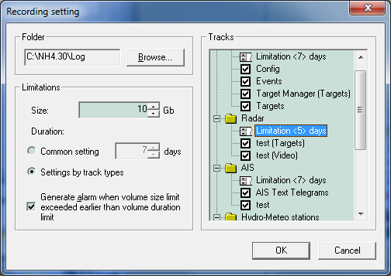

Figure 6‑35 Recording Settings

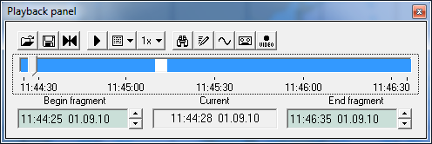

Figure 6‑36 Playback panel



Figure 6‑37 Recording Panel

### Playback system

Playback ODU is a software which can be integrated in Navi-Harbour ODU (can be running in parallel with On-line work without interference) or used as a stand-alone Debriefing System.

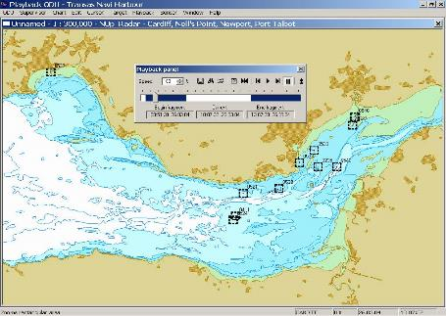

Figure 6‑38 Playback ODU

Playback ODU provides presentation of the all recorded data (playback) in an ODU ordinary graphic environment (all usual operations such as radar image control, scaling, off-centring, electronic measurements are accessible in the playback). Following additional features are available during playback:

* Selecting playback fragment.
* Increasing/decreasing speed of playback.
* Displaying of recorded tracks with possibility to select any combination of tracks for playing back.
* Searching for recorded fragment by user specified criteria (target name, MMSI, Callsign).
* Saving selected record fragment to specified drive\folder.
* Export tracked target data from selected fragment to text format.
* Export recorded audio data to Wav-format
* Printing out of graphic image during playback.
* Capture video-file from playback data.
* Audio records analysis mode provides wide set of features for analysis of voice records:
* graphic presentation of voice activities in time line;
* continuous playing back of audio records without “holes”;
* selecting of audio fragment for continuous repeating.

# Terms and abbreviations

|  |  |
| --- | --- |
| **A** |  |
| AC | Alternative Current |
| AFC | Automatic frequency control |
| AIS | Automatic Identification System |
| AtoN | Aids to Navigation |
| AVI | Audio Video Interleave |
| **B** |  |
| BP | Bearing Pulses |
| BITE | built-in test equipment |
| **D** |  |
| DB | Database |
| DC | Direct Current |
| DGPS | Differential Global Positioning System |
| **E** |  |
| ECDIS | Electronic Chart Display Information System |
| EMI | Electro Magnetic Interference |
| EMU | Environmental Monitoring Unit |
| **G** |  |
| GNSS | Global Navigation Satellite Systems |
| GPS | Global Positioning System |
| GUI | Graphical User Interface |
| **H** |  |
| HM | Heading Mark |
| **I** |  |
| I.A.L.A | International Association of Lighthouse Authorities |
| IPE | Interface Protocol Extender |
| **L** |  |
| LAN | Local Area Network |
| LED | Light-Emitting Diode |
| **M** |  |
| MMSI | Maritime Mobile Service Identity |
| **N** |  |
| NTP | Network Time Protocol |
| **O** |  |
| ODU | Operator Display Unit |
| ORS | Open Radar Supervisor |
| **P** |  |
| PC | Personal Computer |
| PRF | Pulse Repetition Frequency |
| PTT | Push to Talk |
| **R** |  |
| RCI | Remote Control Interface |
| RDF | Radio Direction Finder |
| RFI | Radio Frequency Interference |
| RPB | Radar Processing Board |
| **S** |  |
| SCU | System Control Unit |
| SNMP | Simple Network Management Protocol |
| SSN | SafeSeaNet |
| **T** |  |
| TMU | Tape Monitor Unit |
| **U** |  |
| UAIS | Universal Automatic Identification System |
| UPS | Uninterrupted Power Supply |
| UTC | Universal Time Coordinated |
| **V** |  |
| VHF | Very High Frequency |
| VOIP | Voice Over IP |
| VTMIS | Vessel Traffic Management and Information System |

System Technical Description

Project: ABP Southampton VTS

Project code: STC-TME-C-00194-CS-01

Date of issue: November 2022

Technical support

Wärtsilä Voyage Limited

Phone number: +46 771 460 100

Email: voyage.support@wartsila.com

Web: [www.wartsila.com](http://www.wartsila.com)